UNIVERSITY OF GAZIANTEP

ELECTRICAL AND ELECTRONICS ENGINEERING DEPARTMENT

EEE 241 DIGITAL DESIGN I

LABORATORY EXPERIMENT - 3

FPGA IMPLEMENTATION OF BASIC LOGIC CIRCUITS I

1. OBJECT

In this experiment you will implement some basic logic gates and circuits on FPGA by using Verilog HDL and synthesizer.

2. EXPERIMENTAL WORK

E1. Write the Verilog code for 2-input AND Gate, 3-input NAND Gate and 4-input OR Gate. When you complete your design, synthesize it and have your circuit verified by lab instructor.

E2. Design the circuit given below using Verilog. Obtain its truth table. When you complete your design, have your circuit verified by lab instructor.
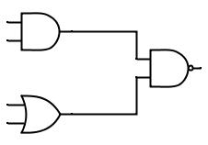

A

B

C

D

Note: Your module structure must be like this:

module Lab1_E2(
input A,
input B,
input C,
input D,
output E
);

