**EEE411**

**DIGITAL ELECTRONICS**

**EXPERIMENT 1**

**RC CIRCUITS**

**1.1 OBJECTIVE:**

Determine the 3_dB cut-off frequency of low-pass and high-pass filtercircuits.

**1.2 THEORY:**

**1.2.1 LOW-PASS FILTER:**

In low-pass RC filter as shown in fig.1 , a series resistor is connected between the input and output of the filter , while the capacitor shunts the output voltage from the filter.At low frequencies , when its reactance is high , the effect of capacitor is negligible.At high frequencies , however the capacitive reactance is small , tending the short circuit the output, so that the output voltage falls.

**For a low-pass RC filter , the transfer function amplitude equation is :**

Vo/Vin = 1/(1+w²R²C²)½

If w=1/RC then the above expression reduces to

Vo/Vin = (1/ 2)½ = 0.707 = -3dB

A low-pass RC filter is usually known as an **INTEGRATOR** when the circuit time constant is long compared to the duration of the input pulse.

**RC>>Tin**

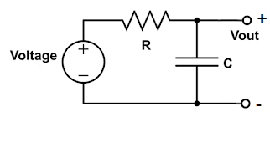 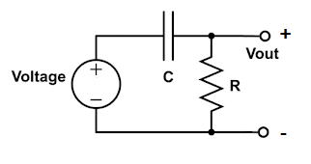

**Fig.1 Low-pass filter Fig.2 High-pass filter**

**1.2.2 HIGH-PASS FILTER :**

A high-pass RC filter network consists of a resistor and a capacitor connected in series with the output taken across the resistor , as shown in Fig.2

At high frequencies , the output voltage increases.This effect results from the decreasing reactance of the capacitor with an increase in frequency.

**For a high-pass RC filter , the transfer function amplitude equation is:**

Vo/Vin = 1/(1+1/(w²R²C²))½

If W = 1/RC then the above expression reduces to

Vo/Vin = (1/2)½ = 0.707 = -3dB

A high-pass RC filter circuit is known as a **DIFFERENTIATOR** when its time constant is short.The RC time constant is most often made small in comparison to the input pulse duration by reducing the value of the capacitor.Such circuits are used to develop a series of sharp positive and negative spikes of output voltage from a square wave of voltage applied to the input terminals.This process is known as differentiation because the output voltage represents the rate of change of input voltage.

**RC<<Tin**

**1.3 PRELIMINARY WORK:**

**P1)**For Fig.1 and 2 find the _3dB cut-off frequency.(If R=1K , C=100 nF and R=2K , C=100 nF)

**1.4 EXPERIMENTAL PROCEDURE:**

1. Set up the circuit given in Fig.1 (R=1K , C=100 nF)
2. Apply a sinusoidal waveform to the circuit.Determine the 3-dB cut-off frequency of low-pass filter circuit.(Vin = 1sin(wt) , f = 100Hz)
3. Apply a square waveform to the circuit and find the frequency at which complete integration is achieved.
4. Repeat part (a) and (b) for R=2K resistor.

**2.)**Set up the circuit given in Fig.2(R = 1K, C=100nF)

**a.)** Apply a sinusoidal waveform to the circuit.Determine the 3_dB cut-off frequency of high-pass filter circuit . (Vin=1sin(wt) , f=10KHz)

**b.)** Apply a triangle waveform to the circuit and find the frequency at which complete differentiation is achieved.

**c.)** Repeat part (a) and (b) for R=2K resistor.

**EQUIPMENT LIST:**

Resistors (1K,2K)

Capacitor (100nF)