EXPERİMENT - 5
NMOS-CMOS INVERTERS
5.1 OBJECTIVE
This experiment aims to explore the fundamental characteristics of NMOS and CMOS inverter circuits. Through the investigation, we will analyze the functioning and behavior of NMOS and CMOS logic gates, specifically focusing on NOT gates and their response to negative potential within the circuit.
5.2 THEORY
Inverters are circuits designed to produce an inverted output relative to their input—for instance, when the input is high, the output is low, and when the input is low, the output becomes high. A MOSFET, or Metal-Oxide-Semiconductor Field-Effect Transistor, is a voltage-controlled current device where the voltage applied between the gate and source regulates the current flow from the drain to the source. There are two main types of MOSFETs: PMOS, where current flow is facilitated by holes, and NMOS, where current flow is driven by electrons. In addition to the drain, source, and gate terminals, MOSFETs also have a substrate or body terminal. For PMOS devices, the substrate is typically connected to the most positive potential within the circuit, whereas in NMOS devices, it is connected to the most negative potential in the circuit.
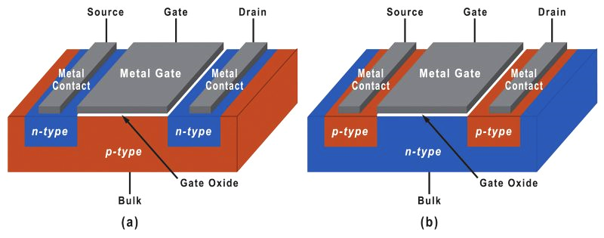
Figure 5.1 NMOS (a) and PMOS (b) MOSFETs.
MOSFET has three regions of operation: Linear (Triode), Saturation and Cutoff.

1. Cutoff Region
- Condition: $V_{GS}$<${ V}_{th}$
  - In this state, the MOSFET remains off.
  - No substantial current flows between the drain and source ($I_{D}$≈0).
  - The channel does not form.

2. Linear (Triode) Region​
- Condition: $V_{GS}$>${ V}_{th}$ and ${ V}_{DS}<{ V}_{GS}-{ V}_{th}$
- Behavior:
  - In this region, the MOSFET functions as a variable resistor.
  - The drain current ${ I}_{D}$ exhibits a linear relationship with the drain-source voltage ${ V}_{DS}$.
  - Current equation: $I_{D}$=${ k}_{n}$ [2($V_{GS}$−$V_{th}$) $V_{DS}-{V_{DS}}^{2}$]
  - Here${ k}_{n}=\frac{μnCoxW}{L}$​ which is a constant dependent on the semiconductor manufacturing process.

3. Saturation (Active) Region
- Condition: : $V_{GS}$>${ V}_{th}$ and ${ V}_{DS}>{ V}_{GS}-{ V}_{th}$
- Behavior:
  - In this region, the MOSFET operates as a constant current source.
As $V_{DS}$ increases further, the drain current $I_{D}$ stops growing and remains constant until the device reaches breakdown. The current in this region, known as the saturation current, can be expressed mathematically as:
$$I_{D}\left(sat\right)={ k}_{n}{{(V}_{GS}-V_{th})}^{2}$$
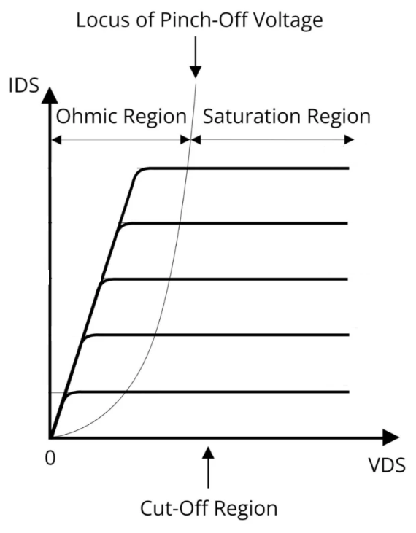
Figure 5.2 I-V Characteristics of an NMOS
The MOSFET IC CD4007, which consists of three NMOS and three PMOS transistors, is utilized in the laboratory setup. Figure 5.3 illustrates the electrical symbols for enhancement-mode NMOS and PMOS transistors, while Figure 5.4 provides the pin configuration details of the CD4007 IC.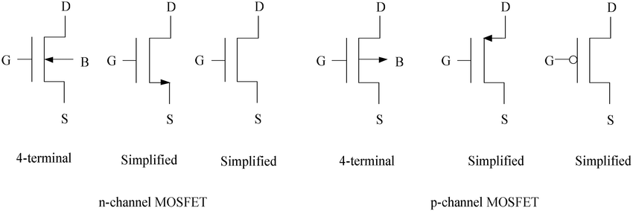

Figure 5.3 Electrical symbols for n-channel and p-channel enhancement type of MOSFETs.
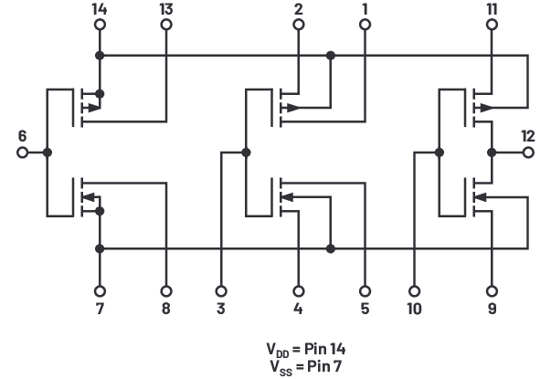
Figure 5.4 CD4007 Pin Configurations
5.2.1 MOS Inverter
Inverter circuits can be designed using n-channel and p-channel MOSFETs found within the CD4007 MOS array chip. Figure 5.3a illustrates an NMOS inverter with a resistive load. On the other hand, the inverter depicted in Figure 5.3b utilizes only NMOS technology. Within NMOS inverters, transistor M₁ functions as the inverter, while transistor M₂ serves as the active load, substituting the static resistor. However, one limitation of these inverters is that their output logic low cannot reach 0V, resulting in reduced noise margins compared to a conventional CMOS inverter. Additionally, DC power is dissipated when the output logic level is low due to the drain current flowing through the circuit. For reference, a CMOS inverter is shown in Figure 5.6. Unlike NMOS-based designs, CMOS inverters exhibit zero static power dissipation, making them more energy-efficient in this regard.
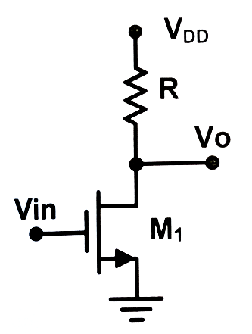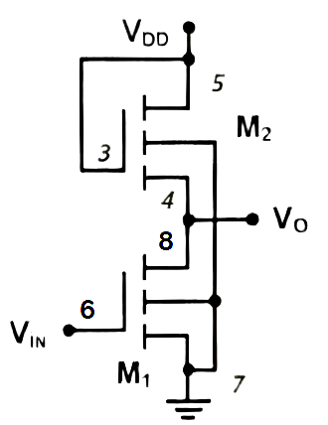
a) b)
Figure 5.5 NMOS inverter with (a) resistive load (b) active load.
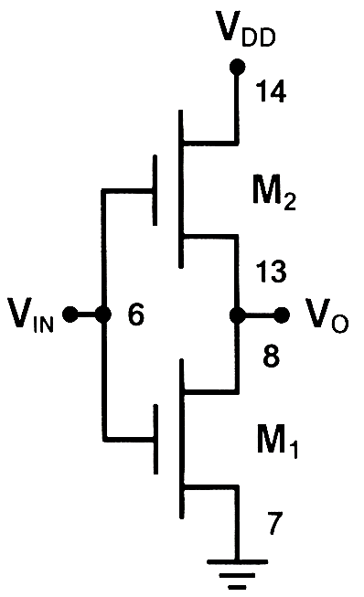
Figure 5.6 CMOS inverter
5.3 PRELIMINARY
R= 47kΩ and $V_{DD}=5V$
k’=150 µA/$V^{2}$, $V_{th}=1.2V, L=2µm, W=10µm, λ=0 for NMOS$
k’=75 µA/$V^{2}$, $V_{th}=-1.0V, L=2µm, W=20µm, λ=0 for PMOS$
5.3.1 For NMOS circuit as shown in Figure 3.5a,
- Sketch the VTC
- Find and replace $V_{OH},V_{OL}{,V}_{IH}{,V}_{IL}$and noise margins listed in Table 5.1.

 | Calculated |  | PSpice |  |  | Experimental
 | 5.5a | 5.6 | 5.5a | 5.5b | 5.6 | 5.5a | 5.5b | 5.6
$$V_{OH}$$
$$V_{OL}$$
$$V_{IH}$$
$$V_{IL}$$
$$NM_{H}$$
$$NM_{L}$$
Table 5.1
5.3.2 Repeat part(5.3.1) for the circuit given in Figure 5.6.

5.3.3 Perform a PSpice analysis (Run a DC sweep from 0V to 5V on the input $V_{in}$) of circuit shown in Figure 5.5a.
- Obtain $V_{o}-V_{in}$ voltage transfer characteristics (VTC) of the circuit.
- Using VTC, find and replace $V_{OH},V_{OL}{,V}_{IH}{,V}_{IL}$and noise margins listed in Table 5.1.

5.3.4 Repeat part(5.3.3) for the circuit given in Figure 5.5b.
5.3.5 Repeat part(5.3.3) for the circuit given in Figure 5.6.

5.5a 5.5b

5.6

5.4 EXPERIMENTAL PROCEDURE
$V_{in}=2.5+2.5sin⁡(2π100t)$, R= 47kΩ and $V_{DD}=5V$
5.4.1 Setup the circuit as shown in Figure 5.5a.
- Observe and plot the VTC.
- Find and replace $V_{OH},V_{OL}{,V}_{IH}{,V}_{IL}$ and noise margins listed in table 5.1.
5.4.2 Repeat part(5.4.1) for the circuit given in Figure 5.5b.
5.4.3 Repeat part(5.4.1) for the circuit given in Figure 5.6.

5.5a 5.5b

5.6

5.5 CONCLUSIONS
5.5.1 Analyze the outcomes of the preliminary and experimental results, highlighting any differences observed. If discrepancies are present, provide a clear explanation of their underlying causes.

5.6 EQUIPMENT LIST
- Resistors : 47kΩ
- IC s : CD4007
- Standart Set Equipment

