**CLASSWORK APPLICATIONS FOR SELECTIVE STRUCTURES 1**

**Q1.** Write a C++ program to determine a given number is odd or even.

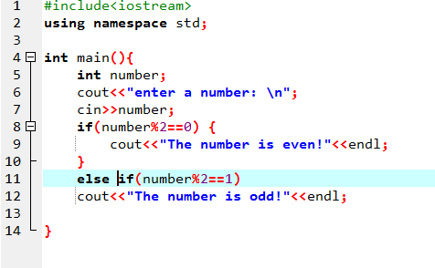

**Q2.** Write a C++ program that determines whether a given temperature is less than or greater than the room temperature (25°C ). If it is exaclty equal to the room temperature, the program displays “the temperature is good!”. If it is less than rooom temperature, the program displays “increase the temperature”. If it is greater, the program displays “decrease the temperature”.

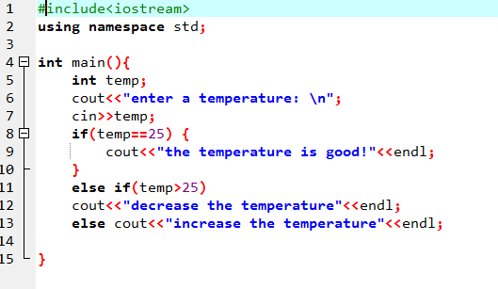

**Q3.** Write the C++ program required to calculate y(t) from the equation



for any values of t.

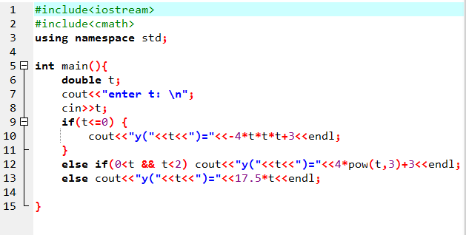

**Q4.** In a mechanical engineering department, a student must enroll for three elective courses during the last term. The student must select three courses from following list of options:

ME 401 KIN. SYNTHESIS OF LINKAGE

ME 405 MECHANICAL VIBRATIONS

ME 407 ELEC.ACTUATIONS OF MECH.SYS.

ME 408 STRENGTH OF MATERIALS 2

ME 410 CENTRIFUGAL PUMP BLOWER

Construct a C++ p rogram that prompts the stu­dent for his or her choice, read in the choice, and use the answer as the case expression for a switch construct. Be sure to include a default case to handle invalid inputs.

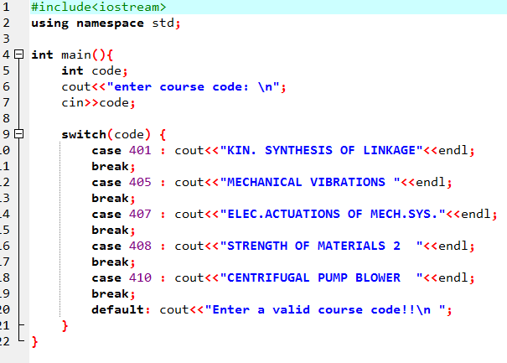

**Q5.** Write a program to read one of the codes “C” for circle, “S” for square, or “T” for a triangle, and a number representing the radius of the circle, the side of the square, or the sides of the triangle, respectively. Then calculate and dis­play the area and the perimeter of that geometric figure with appropriate labels.

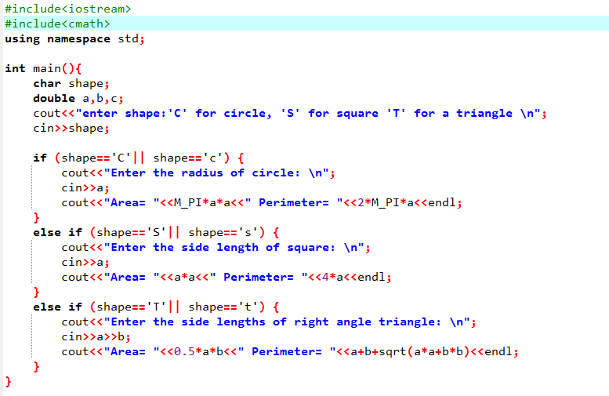

**Q6.** Write a C++ program required to calculate  from the equation



for any values of .

**Q7.** In a shop, the products are coded as follows:

|  |  |  |
| --- | --- | --- |
| Code | Name | Price |
| 01 | LCD | 1050 |
| 02 | Radio | 55 |
| 03 | VCD | 150 |
| 04 | Telephone | 75 |
| 05 | Fax | 150 |
| 06 | Harddisk | 130 |

Write a C++ program to learn the product name and its price when the product code is entered.

**Q8.** Write a C++ program that determines whether a given number is divisible by 15 or not.

**Q9.** Write a program to order three arbitrary numbers that are input from keyboard. Use an increasing order.

