FE 132 ORGANIC CHEMISTRY LABORATORY
EXPERIMENT 10: ALDEHYDES AND KETONES
Introduction
The major similarity between an aldehyde and a ketone is the carbonyl group. A carbonyl group is a carbon atom doubly bonded to an oxygen atom, as depicted below.

Both molecules have a carbonyl group, the aldehyde and ketone differ in what atom is bonded to the carbonyl carbon. The carbonyl carbon of an aldehyde is bonded to two hydrogens or one hydrogen and one carbon. The carbonyl carbon of a ketone is bonded to two carbons. See the below pictures
 |  | 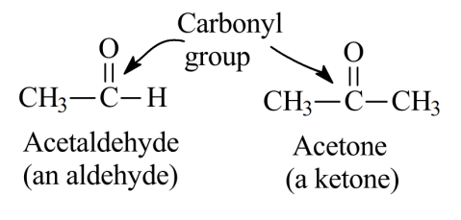
aldehyde | ketone

Remember that the ‘R’ symbolizes any carbon side-chain, from one carbon to a million carbons.
What it comes down to is that in an aldehyde the carbonyl group is on the terminal (last) carbon and the ketones carbonyl group is not.
Where aldehydes and ketones differ
An aldehyde differs from a ketone by having a hydrogen atom attached to the carbonyl group. This makes the aldehydes very easy to oxidize.
For example, ethanal, CH₃CHO, is very easily oxidized to either ethanoic acid, CH₃COOH, or ethanoate ions, CH₃COO-.
Ketones don't have that hydrogen atom and are resistant to oxidation. They are only oxidized by powerful oxidizing agents which have the ability to break carbon-carbon bonds.

Procedure
- Derivatives of Carbonyl compounds
  - 2,4-Dinitrophenylhydrazine derivates
Dinitrophenylhydrazine, DNP for short, reacts with aldehydes and ketones to form a light orange precipitate.
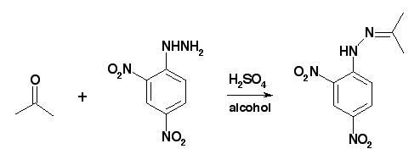
- Take 0.5 ml of 2, 4-DNP in each test tube.
- Add 1 ml of formaldehyde in tube 1 and 1 ml of acetone in tube 2 drop wise.
- Add 0.5 ml of ethanol in each tube.
- Allow to stand at room temperature until crystallization.
- Observe and record the color and shapes of crystals.

Complications
- Some ketones give oils which will not solidify.
- Some allylic alcohols are oxidized by the reagent to aldehydes and give a positive test.
- Some alcohols, if not purified, may contain aldehyde or ketone impurities.
  - Iodoform test for Methyl Ketones
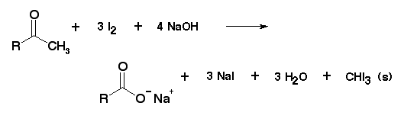
- Dissolve 4 drops of carbonyl compound (acetone) in 2 mL of water in a large test tube.
- Add 3 mL of 10% sodium hydroxide and then slowly add drop wise 10% of the iodine solution.
- Stopper the test tube and shake vigorously.
- A positive test will result in the brown color of the reagent disappearing and the yellow Iodoform solid precipitating out of solution.
- Formation of solid Iodoform (yellow) is a positive test. (Iodoform can be recognized by its odor and yellow color and, more securely, from the melting point 119ºC-123ºC).
- Test for distinguishing between Aldehydes and Ketones
The oxidation of aldehydes can be performed with a mild oxidizing agent, such as Ag⁺ in ammonia solution used in the Tollens test or Cu²⁺ in alkaline solution used in Fehling's test. If the Tollens test is performed in a scrupulously clean glass vessel, the silver metal is plated on the walls of the glass to form a silver mirror. Fehling's reagent is a deep blue Cu²⁺ solution that forms a brick-red precipitate of Cu₂O in the presence of aldehydes.
Tollens’ reagent is used to differentiate between aldehydes and ketones. Aldehydes may be oxidized relatively easily, while ketones are not easily oxidized. The Tollens’ reagent, composed of a silver-ammonium ion, will have its silver reduced by an aldehyde. This silver will plate a glass surface creating a mirror.
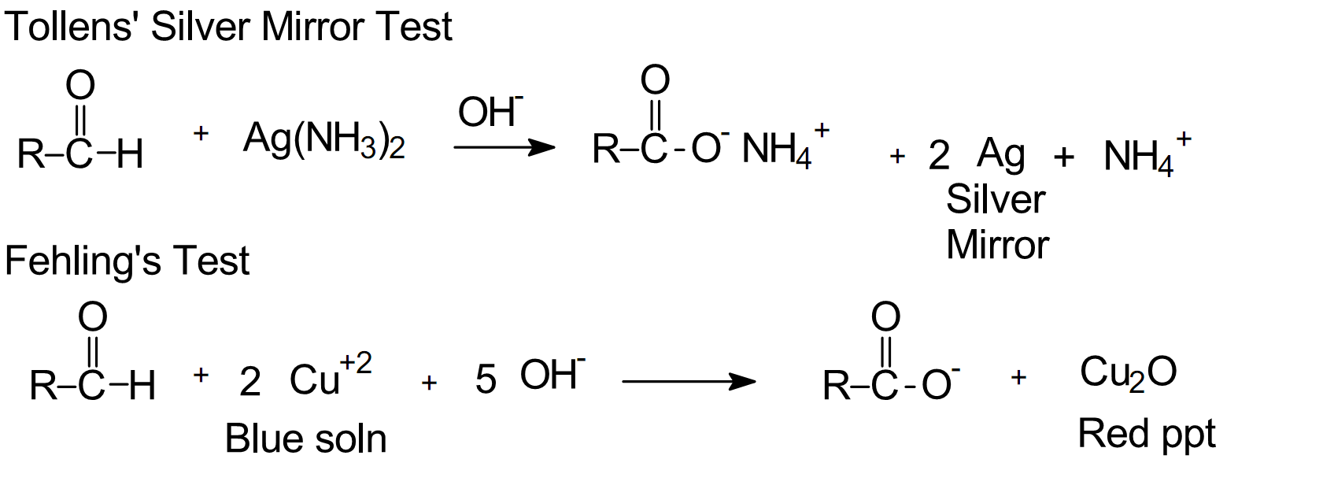
  - Tollens reagent
- Add about 2 mL of 5% silver nitrate solution to each test tube.
- Add 1-2 drops of 10% sodium hydroxide (NaOH) solution to get the brown precipitate.
- Add 6 M ammonia solution dropwise with constant shaking until the brown precipitate completely dissolves.
- Add 3 drops of acetone to tube 1; 3 drops of benzaldehyde to tube 2; 3 drops formaldehyde solution to tube 3.
- Mix each well and allow to stand without further shaking for 5 to 10 min and look for the formation of mirrored glass on the walls of the test tube.
- Record your observations on the Data sheet.
  - Fehling’s test
1. Add 5 mL of Fehling's Solution A to a test tube and mix 5 mL of Fehling's Solution B with it. Notice the change in color of the Cu²⁺ ion when these solutions are mixed.
2. Add about 2 mL of the mixture prepared in step 1 to each of 5 clean test tubes.
3. Add 5 drops of the test compounds (aldehydes/ketones) to the Fehling's reagent in each test tube. Acetone in tube 1; benzaldehyde in tube 2; formaldehyde in tube 3; cyclohexanone in tube 4; and unknown in tube 5.
4. Make sure the tubes are properly labeled before placing them in the boiling water bath.
5. After heating the mixtures for 5 minutes, take note of any changes in color or formation of a precipitate.
6. Record your observations on the Data sheet.
Questions
- Describe the difference between an aldehyde and a ketone, and indicate how each differs from an alcohol.
- Name one aldehyde or ketone that is used widely by consumers. Be sure to give the correct name and indicate its use.
- Which one of the tests performed in this experiment would be most useful in differentiating butanal and benzaldehyde. Explain your answer.
- Why not use ethyl alcohol as a solvent in the Iodoform test?

