10.12.2025
AE 205- Strength of Materials- I
Problem Hour
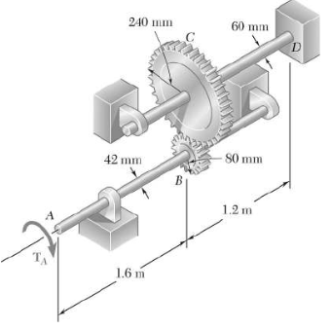
Q1) Two solid shafts are connected by gears as shown. Knowing that $G=77.2 GPa$ for each shaft, determine the angle through which end A rotates when $T_{A}=1200 N.m$.

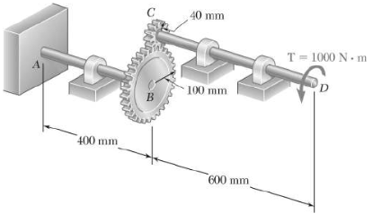
Q2) The design of the gear-and-shaft system shown requires that steel shafts of the same diameter be used for both AB and CD. It is further required that $τ_{max}≤60 MPa$ and that the angle $∅_{D}$ through which end D of shaft CD rotates not exceed 1.5°. Knowing that $G=77 GPa$, determine the required diameter of the shafts.

Q3) The beam shown is made of a nylon for which the allowable stress is 24 MPa in tension and 30 MPa in compression. Determine the largest couple M that can be applied to the beam.

Q4) The composite beam is made of steel (A) bonded to brass (B) and has the cross section shown. Ebr = 100 GPa, Est = 200 GPa. The allowable bending stress for the steel is $\left(σ_{allow}\right)st=180 MPa$, and for the brass $\left(σ_{allow}\right)br=53 MPa$. Determine the maximum moment M that can be applied to the beam.

Q5) Draw the shear and moment diagrams for the beam. Determine the maximum tension and compression stress for steel. Est=210 GPa, Eal=70 GPa.

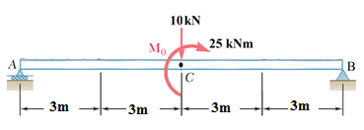
20 mm
Steel
Steel
Aluminum
20 mm
10 mm
40 mm

Ress.Assistant. Mustafa Varki

