01.04.2026
AE 206- Strength of Materials- II
Problem Hour-I
Q1) Forces are applied at points A and B of the solid cast-iron bracket shown. Knowing that the bracket has a diameter of 0.8 in., determine the principal stresses and the maximum shearing stress at (a) point H, (b) point K.
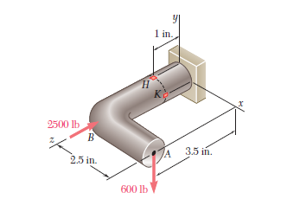

Q2) For the cantilever beam and loading shown, determine (a) the equation of the elastic curve for portion AB of the beam, (b) the deflection at B, (c) the slope at B.

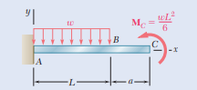

Q3) For the beam and loading shown, determine (a) the equation of the elastic curve for portion AB of the beam, (b) the slope at A, (c) the slope at B.
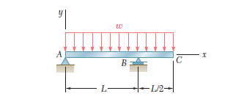
Q4) For the beam and loading shown, determine (a) the slope at end A, (b) the deflection at the midpoint C. Use E = 200 GPa.
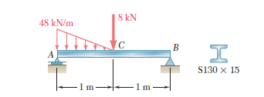

Q5) For the beam shown in the figure, using singularity method, determine,
- The elastic curve equations.
- Slope and deflection of the beam at point C.
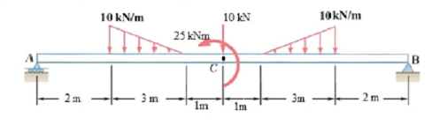
Q2) Several forces are applied to the pipe assembly shown. Knowing that the pipe has inner and outer diameters equal to 1.61 and 1.90 in, respectively, determine the normal and shearing stresses at (a) point H, (b) point K.

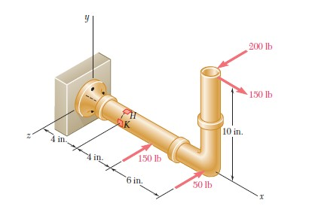

Ress.Assistant. Mustafa Varki

