14.10.2026
AE 205- Strength of Materials- I
Problem Hour
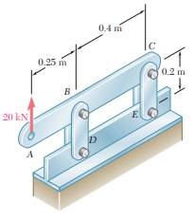
Q1) Each of the four vertical links has an 8x36-mm uniform rectangular cross section and each of the four pins has a 16-mm diameter. Determine the maximum value of the average normal stress in the links connecting (a) points B and D, (b) points C and E.

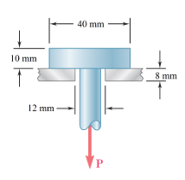
Q2) A load of P is applied to the a steel bar carried by an aluminum plate which have a hole 12 mm diameter hole. Determine the maximum load P can be applied to the rod, in the condition that the shear stress cannot be higher than 180 MPa at steel rod, and 70 MPa at aluminum plate.

Q3) Each of the four vertical links connecting the two rigid horizontal members is made of aluminium (E=70 GPa) and has a uniform rectangular cross section of 10x40 mm. For the loading shown, determine the deflection of point E, point F and point G.
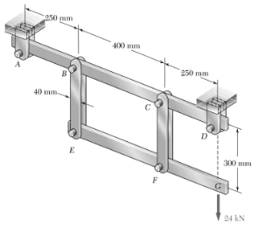

Q4) Two cylindrical rods, one of steel and the other of brass, are joined at C and restrained by rigid supports at A and E. For the loading shown and knowing that Es= 200 GPa and Eb=105 GPa, determine (a) the reactions at A and E, (b) the deflection of point C.

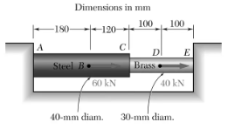

Q5) At room temperature (20°C) a 0.5-mm gap exists between the ends of the rods shown. At a later time when the temperature has reached 140°C, determine:
(a) the normal stress in the aluminum rod,
(b) the change in length of the aluminum rod.

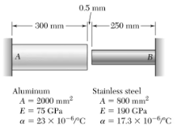

Res. Asst. Mustafa VARKİ

