POLARIMETRY and REFRACTOMETRY

1. Polarimeter
The technique used by polarimeter is called polarimetry, which is based on the rotation of polarized light (the light after passing a polarizer) as it passes through a sample solution (e.g. sucrose solution). Ordinary light has waves (amplitude changes cyclically) spread in all directions (planes). As light passes through a polarizer, a polarized light (a light with a narrow band width in one direction) is formed. If a solution sample changes the angle of polarized light, this indicates the presence of an optically active substance in the sample. The degree of rotation of the polarized light is called the degree of polarization. The degree of polarization is proportional to the concentration of the optically active substances.

Figure 1 shows a principle of a polarimeter set up and its main components together with their function. Unpolarized light from the light source is first polarized. This polarized light passes through a sample cell. If an optical active substance is in a sample tube, the plane of the polarized light waves is rotated. The rotation is noticed by looking through the analyser as a change in intensity of illumination. To reach the same illumination as was without an optical active sample the analyser must be turned around for an angle.

Figure 1. Principle of a polarimeter set up

Figure 2 shows polarizer (P) and analyzer (A) in a perpendicular position with one another. Both have the structure on a molecular level that polarize an unpolarized light. If they are in a position shown no light passes through analyzer.

Figure 2. One of the mutual positions Figure 3. Rotation of polarized light
of a polarizer and an analyzer plane by an optically active
sample

Figure 3 shows the passage of polarized light through a sample tube, which is positioned between polarizer and analyzer. The length of the tube is one of important parameters to be fixed if the measurements were comparable.

1.2.Optical Rotation
Certain compounds, mostly organic rotate the plane of polarized light. The phenomenon is called optical rotation. Materials with these properties are said to have optical activity and consists of chiral molecules (those containing asymmetric carbon atoms). Chirality is the property of an object of being non-superimposable on its mirror image. Chiral centers that have opposite configurations rotate polarized light the same number of degrees, but in opposite directions (enantiomers). Rotation of plane polarized light counterclockwise is levorotation, and rotation of plane polarized light clockwise is dextrorotation. Racemic mixtures (equal parts of two enantiomers) will have no net rotation because the equal but opposite rotations cancel each other.

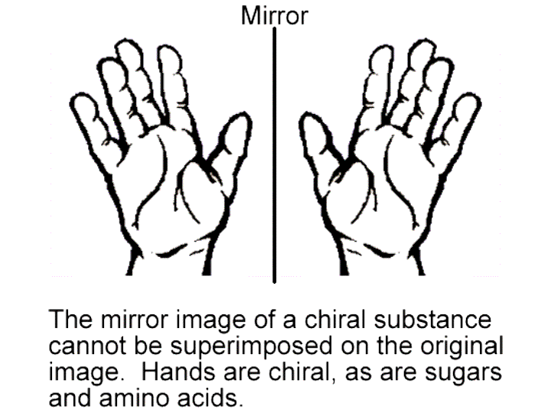

The degree to which a substance rotates light may be used to determine i) the identity of the substance, ii) the enantiomeric purity of the substance or iii) the concentration of a known substance in a solution. The measured angle of rotation depends upon many variables:
-  The type or nature of sample (example: sugar solution)
-  Concentration of the optical active components
-  The length of the sample tube
-  The wavelength of the light source
-  Temperature of the sample

We describe the nature of a sample by introducing the specific optical rotatory power (or specific rotation) of a substance, defined as

${\left[α\right]}_{λ}^{T}$=$\frac{α}{c\text{.}l}$

in SI units: rad m² kg⁻¹ (Notice: 2$α$rad = 360º (deg of angle)) where $α$is the angle of rotation in rad, c  is the mass concentration in kg/m³, and l is the length of the sample tube in m. Specific rotation is determined at a specified temperature T  (usually 20 ºC) and a wavelength ($λ$) of light source (usually sodium lamp with its D line at 589 nm). In practical measurements readings are taken at different units: $α$  in º (deg), c  in g/cm³, l in dm and so ${\left[α\right]}_{\text{589}}^{\text{20}°}$ $α$is usually tabulated in º cm³/g dm. Following table shows the specific rotation of different substances.

Substance  in a solution  H₂O solvent | Specific rotation  $${\left[α\right]}_{\text{589}}^{\text{20}°}$$  (º cm³/g dm)
sucrose | + 66.54
glucose | + 52.74
fructose | - 93.78
maltose | + 137.5
lactose | + 55.3
dextrose | + 194.8

For example:
Sucrose (cane sugar) solution ${\left[α\right]}_{\text{589}}^{\text{20}°}$= + 66.54 º/dm at a concentration of1 g/cm³. The influence of the wavelength of a light source for sugar solutions is seen from the following table:

Description of the  light source | Wavelength  [nm] | Specific rotation  $${\left[α\right]}_{\text{589}}^{\text{20}°}$$  (º cm³/g dm)
Mercury, green | 546.23 | + 78.4178
Sodium, yellow | 589.44 | + 66.5885
HeNe Laser | 632.99 | + 57.2144
Near Infrared (NIR) | 882.60 | + 28.5462

Notice the high precision of specific rotation determined with modern polarimeters.
Temperature dependence of specific rotation for sugar solutions is as follows:

$α$ (t) = $α$ (20.0 ºC)[1.0 – 0.000471 (t – 20.0)]

The following table shows $α$ calculated for some temperatures of a sucrose solution at some concentration:

Temperature ºC | Rotation of a sucrose solution  $α$ (º angle degree)
20 | 40.000
21 | 39.981
25 | 39.906

Notice the decrease of the rotation of sucrose solution with rising temperature. Also the effect of temperature is relatively small.
Polarimetry is a powerful tool to determine the active purity of raw materials such as vitamins, steroids, and antibiotics, since for most chiral compounds, only one isomer (enantimer) has biological activity. From the pharmacological point of wiev, a worst scenario is one which the undesired enantiomer causes serious toxicity. The most common application is for sugar content. Methods for determination of sugar in chocolate, wines, jams, jellies, and flour are well documented, as well as lactose in milk products.
1.3.Polarimetry of sugar solutions
Polarimetry is frequently used for determining the quality of sugar products. Measurements are made by polarimeters or saccharimeters with the scale in angle degrees (º) and sugar degrees (ºZ). Angle of rotation depends linearly on concentration of sugar in the solution, as other parameters (temperature, light source, length of the tube) remain unchanged. Sugar industry with its International commission for Uniform Methods of Sugar Analysis (ICUMSA) introduces International Sugar Scale (ISS) in ºZ units. 100.00 ºZ units (sugar degrees) belong to Normal Sucrose Solution prepared from exactly 26.000 g of sucrose dissolved in pure water to 100 cm³. At 20.0 ºC and D sodium lamp rotation for this solution in a tube of 200 mm will be $α$= +34.626 º. The ISS is linearly divided, i.e. a rotation of +17.313 º (13 g/100 cm³) equals to a reading of 50.00 ºZ. The 0 ºZ point in ISS is fixed by the indication given by the saccharimeter for pure water. Normal Sucrose Solution was used to calibrate and standardize polarimetric methods and instruments. Sugar solutions are not very stable and have to be renewed regularly.

Today quartz control plates are used as a standard for the calibration of polarimeters. Interrelation between both scales is defined from a straight line (y = a.x) equation:

ºZ =$\frac{\text{100}\text{.}\text{00}}{\text{34}\text{.}\text{626}}$. º (deg) = 2.889. º (deg)

2.Refractometry
When light passes from one medium into another, its velocity is changed. The ratio of the velocity of light in a vacuum to that in a substance is known as the index of refraction or refractive index of that substance. The index of refraction varies with the wavelength of light employed, with temperature, and with pressure (for gases).

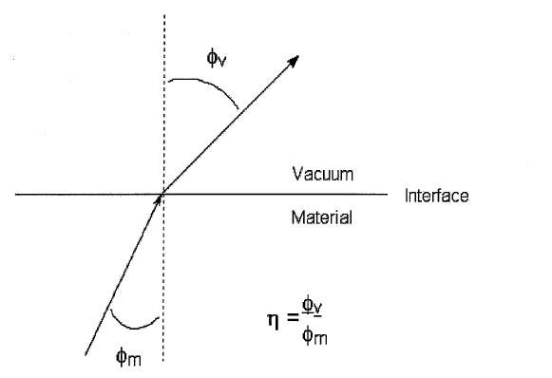

For practical purposes, air is used as a reference instead of vacuum, since its index of refraction is very close to 1.

A variety of instruments, called refractometers, permits the measurement of indices of refraction of gases, liquids, and solids. Refractometry is the term applied to the group of optical methods for the analysis of either relatively pure substances or complex mixtures, based on refractive-index measurements.

Some substances, called isotropic materials, transmit light with equal velocity in all directions and have only one index of refraction. Gases, liquids, glasses, and most solids of the isometric system belong to the isotropic group of materials. Other solids, which do not transmit light with equal velocity in all directions, are called anisotropic materials.

The angle of refraction varies with the wavelength of the light used. Usually the yellow sodium doublet lines are used; they have a weighted mean of 589.26 nm and are symbolized by D.

A typical refractive index would be expressed as

$$η_{D}^{5}=1\text{.}\text{4567}$$

where the superscript indicates the temperature and the subscript indicates the wavelength of the light source.

For water the refractive index is 1.3329 at 20ºC and for most liquids the value falls within the range 1.2 to 2.0. Refractive Index is also a function of temperature. An increase in temperature usually gives rise to a decrease in density and light travels more rapidly through a lower density medium. Refractive Index therefore tends to decrease with increasing temperature. A simple correction can be applied with 95 % confidence limit.

$$η_{D}^{\text{25}}=η_{D}^{y}−(\text{25}\text{.}0−y)(0\text{.}\text{00045})$$

The actual temperature of the measurement is y (in ºC). $η_{D}^{\text{25}}$ is the index of refraction, using the sodium D line, at 25ºC, $η_{D}^{y}$is the index of refraction that you measure at yºC.

2.1.Refractometers

Refractometers are based on two measurement principle as the differential and the critical angle.

In the differential refractometer, a light beam is transmitted through a partitioned cell that refracts the beam at an angle that depends on the difference in refractive index between the sample liquid in one part and a standard liquid in the other.

In the critical-angle refractometer the light incident on the surface of the solution changes sharply from reflected to transmitted light at a critical angle. Most refractometers are based on the critical angle effect, which defines the point of balance, the shadow point or borderline, between refraction and total internal reflection of light at a prism/sample interface.

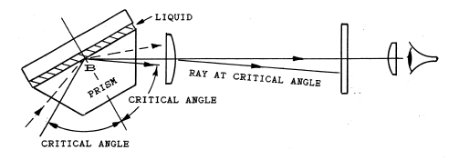

The critical angle is the angle from the perpendicular at which the beam changes from light transmitted into the liquid to light totally reflected at the liquid surface. At angles smaller than the critical angle the light is transmitted into the liquid. The critical angle depends not only on the solution composition but also on the prism material.

The significant feature of a critical angle refractometer is that it measures the refractive index at the surface of a solution. Since surface reflection requires no penetration of the light beam into the solution, this type of refractometer may be used for highly opaque samples and various murky solutions and suspensions, as well as transparent samples.

There are three main types of refractometer: portable hand-held instruments used for ‘on-the-spot’ measurements, high accuracy bench instruments for use in laboratories and process or ‘in-line’ refractometers for monitoring and control in manufacturing processes.

Bench type instruments can be further classified into two types:

Abbé Refractometer. The Abbé refractometer, an example of a critical-angle refractometer, compares the angles at which light from a point source passes through the test liquid and into a prism the refractive index of which is known. A drop of the sample is placed between the upper and lower prisms and, following the directions supplied by the manufacturer, the refractive index of the sample is read from the dial.

Differential refractometers. Differential refractometers are intended primarily for the analysis of liquid mixtures. They are applicable to any mixture whose refractive index is a singlevalued function of the composition; as such they are uniquely applicable as detectors in high-performance liquid chromatography in which they monitor the difference in refractive index between the mobile phase (reference) and the column effluent. The sensitivity of differential refractometers is 0.000 001 refractive-index units. Liquid samples must be clear and clean.

The range of the Abbé refractometer is normally 1.3000 to 1.7000, the maximum precision attainable being 0.0001. This refractometer reads the refractive index directly and requires only a drop of sample.

2.2.Practical Applications

More generally, refractometers are used to measure a refractive index of pure substances (liquid) as a unique characteristic, or used to measure the concentration of one substance dissolved in another. Refractometry is therefore an ideal technique for Quality Control in many industries. The most common uses of refractometers are in the food and drink industries where the dissolved solids content of liquid food products is measured as a ‘Brix value’.

Brix is simply the name given to the scale which is based on the relationship between sucrose concentration (%w/w) and Refractive Index. Thus, the Brix scale can be used to measure the concentration of cane sugar (=sucrose) in water. The Brix scale is based on solutions of pure sucrose in water, with concentration expressed as weight %. Accurate measurements at 20 °C of density and refractive index (at 589.3 nm) of sucrose solutions and the relationships to concentration have been adopted by International Commission for Uniform Methods of Sugar Analysis (ICUMSA) and are used throughout the world for measuring the dissolved solids (mainly sugars) of liquid food products.

Food products can contain many types of sugar and other soluble components such as acids, salts, colour and flavour agents. However, the Brix scale is used regardless of the composition of the aqueous phase. Strictly speaking, for non-sucrose based products, measurements should perhaps be expressed as ‘apparent Brix’ or ‘sucrose equivalents’. ‘TS’ or ‘TDS’ is also used frequently, again incorrectly since Total Solids or Total Dissolved Solids implies that the relationship is relevant to all solids not just sugar solids.

Brix is used generally as a measure of ‘solids content’ for the purpose of quality control. Many food and drink products have a ‘Brix value’. This is because they are tested using a refractometer equipped with the Brix scale. However many users misunderstand what the ‘Brix’ of a product actually means. Most products tested using the Brix scale do not contain sucrose at all. The main exception is in the sugar industry – obviously! Even soft drinks that are made from sucrose undergo ‘inversion’ (decomposition to form 50:50 fructose and glucose) caused by the acidity of the drink.

For pure solutions of sucrose in water, the Brix reading is an exact measure of the %(w/w) dissolved sucrose. However, some people think that the Brix is a measure of % dissolved solids for all products. This is not true; for non-sucrose-based products, the ‘Brix value’ is simply a convenient relative measure of solids content but is not an exact %ww measure.

An 11.40% sucrose (Brix) solution has a refractive index of 1.3500. The same refractive index the region of 1.60 refractive index , can then be measured on an Abbe refractometer chloride solutions using the Brix scale, a conversion table or equation relating sodium chloride concentration to sucrose (equivalent) concentration is needed.

The Brix of a product is a very reliable parameter in quality control and is therefore used for this purpose. There are many, many possible refractometer scales that could be created, but in practice only a few are used. The Brix scale, as explained, serves as a general scale for quality assurance of many liquid food products. There are available other sugar scales such as glucose, fructose and invert sugar. These can be used by (typically) syrup manufacturers who wish to have an exact measure of dissolved solids for specific (non-sucrose) sugar solutions.

Salt scales (sodium chloride, artificial seawater) are used for checking brines, e.g. in fish farming. Ethylene and propylene glycol scales are used to check the concentration of antifreeze fluids. A % water-in-honey scale is used specifically by beekeepers to check moisture content of honey, which is a very important quality parameter. The wine and beer industries have devised quite a number of industry-specific scales.

The Brix value (more correctly termed ’apparent Brix’ for non-sucrose based products) gives a measure of the total dissolved solids (mainly/all sugars) in a product. However, in practice, refractometers are used to measure a variety of samples, many of which prove ‘difficult’. In addition to ideal, optically-clear samples, test materials include: suspensions, emulsions, gels, pastes and even ‘solid like’ samples. Furthermore, many of these samples are often intensely coloured. Examples in the food industry include tomato paste, jams, ‘pulpy juices’, sauces, liquorice, yeast and vegetable extracts and many more.

In addition to the ‘dissolved solids’ which is usually the measurable quantity by refractometry, many liquid food products or ingredients contain a host of suspended material. Thus fruit-based liquids may contain cellular ‘debris’ – cellulosic and insoluble proteinaceous materials. Other natural products may contain suspended oils and fats and possibly surface active components such as fatty acids and their derivatives. Some of these ‘insolubles’ may be present as large particles, some maybe present as micron-sized particles/droplets (e.g. emulsions) and some may be in colloidal form.

In addition to above mentioned applications,
- in the Edible Oil Industry refractometers are normally used for characterising oils according to their refractive index (RI). This must be done at a fixed temperature because refractive a blend of two different edible oils by the refractive index. There has been a lot of effort given to establishing an indirect method, which involves the measurement of refractive index and the use of empirical equations to correlate refractive index with iodine value in oils to determine the degree of unsaturation.
- Biofuel is based on a mixture of diesel and palm oil. The two ‘oils’ are blended together at a specific ratio (typically 70 parts diesel and 30 parts palm oil). A refractometer may be used to control the blend ratio and form part of research experiments.
- Systems incorporating refractometers and density meters (refractive index /specific gravity) for the determination of alcohol are widely used in both the brewing of beer and bottling of wine.
- By adding the chemical monobromonapthalene, the resultant solution, somewhere in the region of 1.60 refractive index, can then be measured on an Abbe refractometer

3.Experimental Determination of a Sugar Solution

In this experiment a sugar solution of known concentration (c), but unknown identity will be identified by measuring the observed rotation, $α$. This data will be used to calculate the specific rotation, ${\left[α\right]}_{λ}^{T}$. The observed rotation of sucrose and invert sugar will be measured.

Sample Preparation and Procedure:
- Inspect the polarimeter
- Weigh out approximately 0.5 g of unknown in a beaker. Record all the digits of this mass in your notebook.
- Swirl the contents until all of the solid is dissolved after adding 10 ml water
- Carefully transfer this solution to a 25ml volumetric flask and fill the flask with distilled water upto the mark
- Calculate the concentration in g/ml.
- Obtain the $α$ by analyzing your solution in the polarimeter using the
- instructions of the instrument.
- Using the above equation, calculate the specific rotation.
- Select the identity of your material from the list provided.
- Disscuss the possible factors that affect your result.
- Calculate the percent error.
- Repeat the same procedure for measuring the observed rotation of invert sugar. Disscuss the differences from the sucrose solution

