FE 315 INSTRUMENTAL ANALYSIS

FOURIER TRANSFORM INFRARED SPECTROSCOPY

Instructor: Prof. Dr. Çiğdem AYKAÇ

THEORY

What is Infrared?
Infrared radiation lies between the visible and microwave portions of the electromagnetic spectrum. Infrared waves have wavelengths longer than visible and shorter than microwaves, and have frequencies which are lower than visible and higher than microwaves.
The Infrared region is divided into: near, mid and far-infrared. Near-infrared refers to the part of the infrared spectrum that is closest to visible light and far-infrared refers to the part that is closer to the microwave region. Mid-infrared is the region between these two.
The primary source of infrared radiation is thermal radiation (heat). It is the radiation produced by the motion of atoms and molecules in an object. The higher the temperature, the more the atoms and molecules move and the more infrared radiation they produce. Any object radiates in the infrared. Even an ice cube, emits infrared.
Infrared Spectroscopy
The bonds between atoms in the molecule stretch and bend, absorbing infrared energy and creating the infrared spectrum.

Symmetric Streching
Antisymmetric Streching
Bending

A molecule such as H₂O will absorb infrared light when the vibration (stretch or bend) results in a molecular dipole moment change

A molecule can be characterized (identified) by its molecular vibrations, based on the absorption and intensity of specific infrared wavelengths.
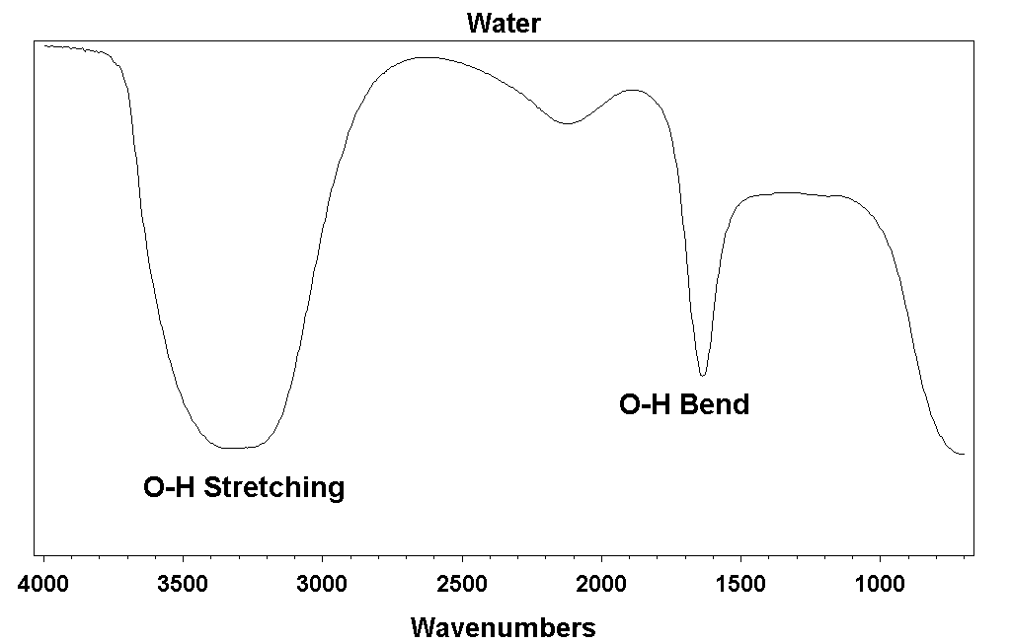

Why Infrared Spectroscopy?
Infrared spectroscopy has been a workhorse technique for materials analysis in the laboratory for over seventy years. An infrared spectrum represents a fingerprint of a sample with absorption peaks which correspond to the frequencies of vibrations between the bonds of the atoms making up the material.
Because each different material is a unique combination of atoms, no two compounds produce the exact same infrared spectrum. Therefore, infrared spectroscopy can result in a positive identification (qualitative analysis) of every different kind of material. In addition, the size of the peaks in the spectrum is a direct indication of the amount of material present. With modern software algorithms, infrared is an excellent tool for quantitative analysis.

What is Fourier Transform Infrared Spectroscopy (FT-IR) ?
FT-IR stands for Fourier Transform InfraRed, the preferred method of infrared spectroscopy. In infrared spectroscopy, IR radiation is passed through a sample. Some of the infrared radiation is absorbed by the sample and some of it is passed through (transmitted). The resulting spectrum represents the molecular absorption and transmission, creating a molecular fingerprint of the sample. Like a fingerprint no two unique molecular structures produce the same infrared spectrum. This makes infrared spectroscopy useful for several types of analysis.

What information can FT-IR provide?
• It can identify unknown materials
• It can determine the quality or consistency of a sample
• It can determine the amount of components in a mixture

Working Principle of FT-IR?

The interferometer produces a unique type of signal which has all of the infrared frequencies “encoded” into it. The signal can be measured very quickly, usually on the order of one second or so. Thus, the time element per sample is reduced to a matter of a few seconds rather than several minutes. Most interferometers employ a beamsplitter which takes the incoming infrared beam and divides it into two optical beams. One beam reflects off of a flat mirror which is fixed in place. The other beam reflects off of a flat mirror which is on a mechanism which allows this mirror to move a very short distance (typically a few millimeters) away from the beamsplitter. The two beams reflect off of their respective mirrors and are recombined when they meet back at the beamsplitter. Because the path that one beam travels is a fixed length and the other is constantly changing as its mirror moves, the signal which exits the interferometer is the result of these two beams “interfering” with each other. The resulting signal is called an interferogram which has the unique property that every data point (a function of the moving mirror position) which makes up the signal has information about every infrared frequency which comes from the source. This means that as the interferogram is measured, all frequencies are being measured simultaneously. Thus, the use of the interferometer results in extremely fast measurements.

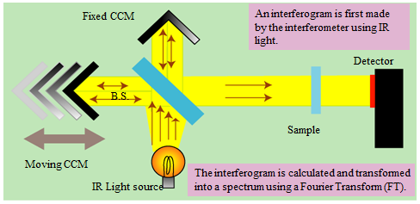

Because the analyst requires a frequency spectrum (a plot of the intensity at each individual frequency) in order to make identification, the measured interferogram signal can not be interpreted directly. A means of “decoding” the individual frequencies is required. This can be accomplished via a well-known mathematical technique called the Fourier transformation. This transformation is performed by the computer which then presents the user with the desired spectral information for analysis.

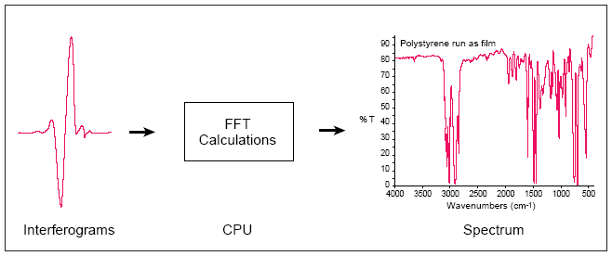

The normal instrumental process is as follows:
1. The Source: Infrared energy is emitted from a glowing black-body source. This beam passes through an aperture which controls the amount of energy presented to the sample (and, ultimately, to the detector).
2. The Interferometer: The beam enters the interferometer where the “spectral encoding” takes place. The resulting interferogram signal then exits the interferometer.
3. The Sample: The beam enters the sample compartment where it is transmitted through or reflected off of the surface of the sample, depending on the type of analysis being accomplished. This is where specific frequencies of energy, which are uniquely characteristic of the sample, are absorbed.
4. The Detector: The beam finally passes to the detector for final measurement. The detectors used are specially designed to measure the special interferogram signal.
5. The Computer: The measured signal is digitized and sent to the computer where the Fourier transformation takes place. The final infrared spectrum is then presented to the user for interpretation and any further manipulation.

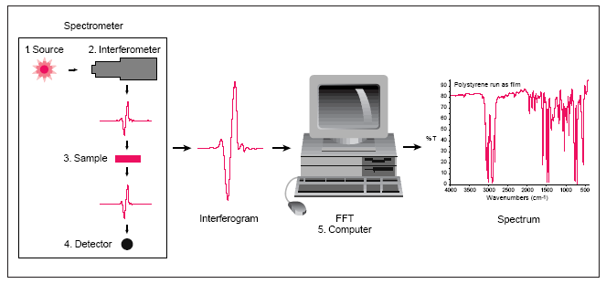

Because there needs to be a relative scale for the absorption intensity, a background spectrum must also be measured. This is normally a measurement with no sample in the beam. This can be compared to the measurement with the sample in the beam to determine the “percent transmittance.” This technique results in a spectrum which has all of the instrumental characteristics removed. Thus, all spectral features which are present are strictly due to the sample. A single background measurement can be used for many sample measurements because this spectrum is characteristic of the instrument itself.

A Simple Spectrometer Layout

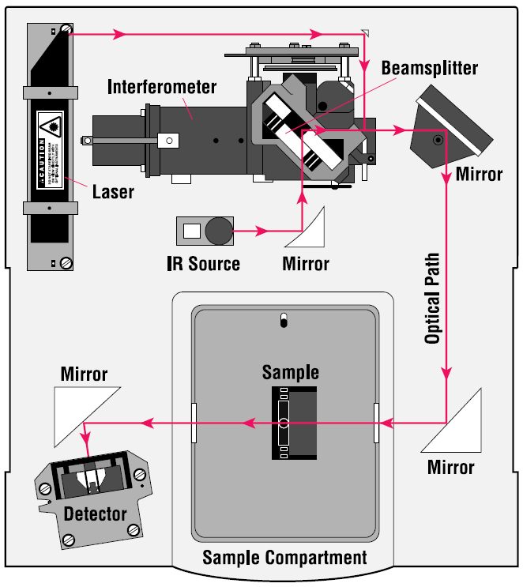

Advantages of FT-IR
Some of the major advantages of FT-IR over the dispersive technique include:
• Speed: Because all of the frequencies are measured simultaneously, most measurements by FT-IR are made in a matter of seconds rather than several minutes. This is sometimes referred to as the Felgett Advantage.
• Sensitivity: Sensitivity is dramatically improved with FT-IR for many reasons. The detectors employed are much more sensitive, the optical throughput is much higher (referred to as the Jacquinot Advantage) which results in much lower noise levels, and the fast scans enable the coaddition of several scans in order to reduce the random measurement noise to any desired level (referred to as signal averaging).
• Mechanical Simplicity: The moving mirror in the interferometer is the only continuously moving part in the instrument. Thus, there is very little possibility of mechanical breakdown.
• Internally Calibrated: These instruments employ a He-Ne laser as an internal wavelength calibration standard (referred to as the Connes Advantage). These instruments are self-calibrating and never need to be calibrated by the user.
These advantages, along with several others, make measurements made by FT-IR extremely accurate and reproducible. Thus, it is a very reliable technique for positive identification of virtually any sample. The sensitivity benefits enable identification of even the smallest of contaminants. This makes FT-IR an invaluable tool for quality control or quality assurance applications whether it is batch-to-batch comparisons to quality standards or analysis of an unknown contaminant. In addition, the sensitivity and accuracy of FT-IR detectors, along with a wide variety of software algorithms, have dramatically increased the practical use of infrared for quantitative analysis. Quantitative methods can be easily developed and calibrated and can be incorporated into simple procedures for routine analysis.
Thus, the Fourier Transform Infrared (FT-IR) technique has brought significant practical advantages to infrared spectroscopy. It has made possible the development of many new sampling techniques which were designed to tackle challenging problems which were impossible by older technology. It has made the use of infrared analysis virtually limitless.

Attenuated Total Reflectance (ATR) is used for surface analysis of soft samples and liquids. See figures below. The sample is put on top of the blue crystal. The IR beam picks up a signal since it passes a few micron into the sample before it is reflected. It is therefore important to obtain good contact between the crystal and the sample. This can be achieved by pressing the sample down on the crystal as shown in the right hand image. If the substance under study is a liquid, it is simply dropped onto the crystal, thereby obtaining optimal contact.
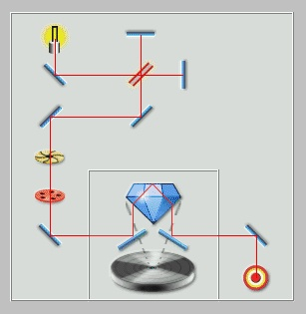  Light path in the ATR setup. | 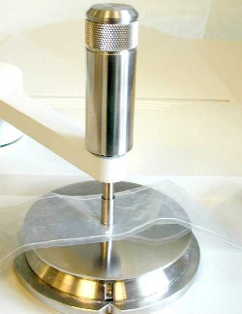  Equipment to push the sample onto the crystal.

Potassium bromide (KBr) does not influence the IR spectrum in the wave number range 4000 til 400 cm⁻¹. This technique can be used when the sample material can be crushed or ground. A couple of milligram of sample is mixed with about 200 mg of KBr powder. The mixture is pressed into a tablet which is then used in the analysis.
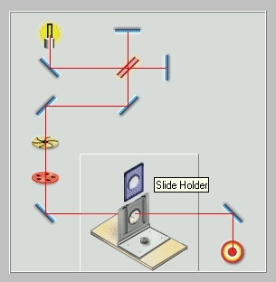  Light path with the KBr-technique. | 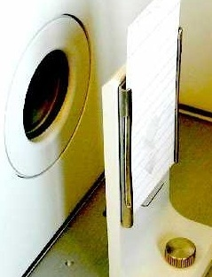  Sample holder with a KBr-tablet, ready  to be analysed in the sample chamber.

Microscope: With a microscope one can analyze very small samples, down to 5 µm x 5 µm. Both transmission and reflection techniques can be used.
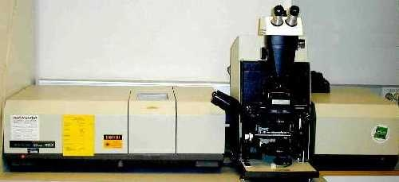
FT-IR Microscope

Other methods: There are a number of other IR techniques, among others:
- Specular reflectance is used to analyse thin layers on metals.
- Diffuse reflectance is used to analyse powder samples. The powder is put in a separate holder which is especially made for this method.
- By using special cells one can also analyse gases.
- Quantitative analysis is possible, but is more complicated and time-consuming.

EXPERIMENTAL PROCEDURE
There are three main classes of triglycerides—saturated fats, and unsaturated trans-fats and cis-fats. Unsaturation indicates the triglyceride contains one or more carbon–carbon double bonds. Most natural oils like vegetable oil consist of cis-fats and are poly-unsaturated, meaning they contain more than one double bond. The cis nature prevents solidification of the fat; trans-fats solidify more readily, which can lead to blockages in the bloodstream.
Fourier transform infrared (FT-IR) spectroscopy functions well to analyse trans-fats. The vibrational absorptions of fats show C–H bands around 2800–3000 cm^{–1} and the C=O band between 1600 cm^{–1} and 1800 cm^{–1}. Critically, intra- and intermolecular interactions shift the peaks, allowing IR to distinguish between cis and trans (and saturated) fats.
Olive oil, margarine and butter will be tested by FTIR/ATR microscope to distinguish them in relation to their cis and trans fatty acid content. Before testing each sample a background spectrum will be recorded with an air emittance spectrum. Each sample will be tested by putting small amount of them on to the crystal and measured between a frequency range 4000-650 cm⁻¹ twice and recorded to computer. Then olive oil, margarine and butter will be heated and heated samples will be tested for change in cis and trans fatty acid contents.

