FE 315 INSTRUMENTAL ANALYSIS
UV-VIS SPECTROPHOTOMETRY
Instructor: Dr. Sibel Fadıloğlu
Spectrophotometry is an important branch of spectroscopy that focuses on the technique of measurement. In this technique, the amount of light that a sample absorbs at a particular wavelength is measured and used to determine the concentration of the sample by comparison with appropriate standards or reference data.
Ultraviolet and visible spectrometers have been in general use for the last 35 years and over this period have become the most important analytical instrument in the modern day laboratory. In many applications other techniques could be employed but none rival UV-Visible spectrometry for its simplicity, versatility, speed, accuracy and cost-effectiveness.
The basic parts of a spectrophotometer are a light source, a holder for the sample, a diffraction grating or monochromator to separate the different wavelengths of light, and a detector. The radiation source is often a Tungsten filament (300-2500 nm), a deuterium arc lamp, which is continuous over the ultraviolet region (190-400 nm) or more recently, light emitting diodes (LED) and Xenon arc lamps for the visible wavelengths.
A spectrophotometer can be either single beam or doble beam. In a single beam instrument, all of the light passes through the sample cell. P₀ must be measured by removing the sample This was the earliest design, but is still in common use in both teaching and industrial labs. In a double-beam instrument, the light is split into two beams before it reaches the sample. One beam is used as the reference; the other beam passes through the sample. The reference beam intensity is taken as 100% Transmission (or 0 Absorbance), and the measurement displayed is the ratio of the two beam intensities. Some double-beam instruments have two detectors (photodiodes), and the sample and reference beam are measured at the same time. In other instruments, the two beams pass through a beam chopper, which blocks one beam at a time. The detector alternates between measuring the sample beam and the reference beam in synchronism with the chopper.
Samples are typically placed in a transparent cell, known as a cuvette. Cuvettes are typically rectangular in shape. The most widely applicable cuvettes are made of high quality fused silica or quartz glass because these are transparent throughout the UV, visible and near infrared regions. Glass and plastic cuvettes are also common, although glass and most plastics absorb in the UV, which limits their usefulness to visible wavelengths.
For convenience of reference, definitions of the various spectral regions have been set by the Joint Committee on Nomenclature in Applied Spectroscopy (Table 1).

Table 1. Spectral Regions
Region | Wavelength (nm)
Far ultraviolet | 10-200
Near ultraviolet | 200-380
Visible | 380-780
Near infrared | 780-3000
Middle infrared | 3000-30,000
Far infrared | 30,000-300,000
Microwave | 300,000-1,000,000,000
The visible spectrum constitutes but a small part of the total radiation spectrum. Most of the radiation that surrounds us cannot be seen, but can be detected by dedicated sensing instruments. This electromagnetic spectrum ranges from very short wavelengths (including gamma and x-rays) to very long wavelengths (including microwaves and broadcast radio waves). The following chart displays many of the important regions of this spectrum.

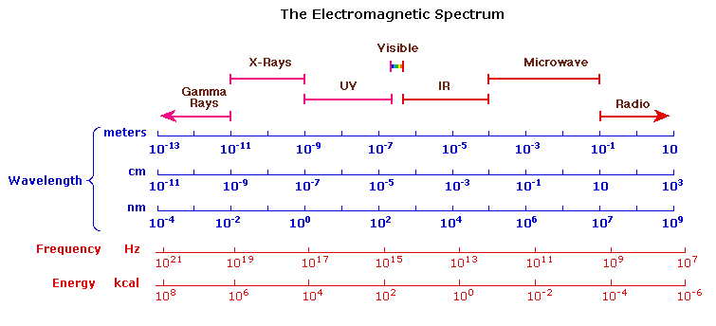

The human eye is only sensitive to a tiny proportion of the total electromagnetic spectrum between approximately 380 and 780 nm and within this area we perceive the colors of the rainbow from violet through to red. When white light falls upon a sample, the light may be totally reflected, in which case the substance appears white or the light may be totally absorbed, in which case the substance will appear black. If, however, only a portion of the light is absorbed and the balance is reflected, the color of the sample is determined by the reflected light. Thus, if violet is absorbed, the sample
appears yellow-green and if yellow is absorbed, the sample appears blue. The colors are described as complementary. However, many substances which appear colorless do have absorption spectra. In this instance, the absorption will take place in the infra-red or ultraviolet and not in the visible region. Table 2 illustrates the relationship between light absorption and color.

Table 2. Relationship between light absorption and color
Color absorbed | Color observed | Absorbed radiation (nm)
Violet | Yellow-green | 400-435
Blue | Yellow | 435-480
Green-blue | Orange | 480-490
Blue-green | Red | 490-500
Green | Purple | 500-560
Yellow-green | Violet | 560-580
Yellow | Blue | 580-595
Orange | Green-blue | 595-605
Red | Blue-green | 605-750

Methods based on the absorption of radiation are powerful and useful tools for the analytical chemist. The ultraviolet region is particularly important for the qualitative and quantitative determination of many organic compounds. In the visible region, spectrophotometric methods are widely used for the quantitative determination of many trace substances, especially inorganic species.
UV/Vis spectroscopy is routinely used in the quantitative determination of solutions of transition metal ions and highly conjugated organic compounds.
- Solutions of transition metal ions can be colored (i.e., absorb visible light) because d electrons within the metal atoms can be excited from one electronic state to another. The colour of metal ion solutions is strongly affected by the presence of other species, such as certain anions or ligands. For instance, the colour of a dilute solution of copper sulfate is a very light blue; adding ammonia intensifies the colour and changes the wavelength of maximum absorption.
- Organic compounds , especially those with a high degree of conjugation, also absorb light in the UV or visible regions of the electromagnetic spectrum. The solvents for these determinations are often water for water soluble compounds, or ethanol for organic-soluble compounds. (Organic solvents may have significant UV absorption; not all solvents are suitable for use in UV spectroscopy. Ethanol absorbs very weakly at most wavelengths).
Having looked at the theory and origins of UV-Visible spectra, let us now investigate how we can apply the technique to chemical analysis starting with consideration of sample state.
With solid sample it is usually found that the material is in a condition unsuitable for direct spectrometry. The refractive index of the material is high and a large proportion of the radiation may be lost by random reflection or refraction at the surface or in the mass. Unless the sample can be easily made as an homogenous polished block or film, it is usual to eliminate these interfaces by dissolving it in a transparent solvent.
Liquids may be contained in a vessel made of transparent material such as silica, glass or plastic, known as a cell or cuvette.The faces of these cells through which the radiation passes are highly polished to keep reflection and scatter losses to a minimum.
Gases may be contained in similar cells which are sealed or stoppered to make them gas tight.

With the sample now ready for measurement, the P₀ (incident intensity) can be set by moving the sample out of the beam and letting the light fall directly on the detector. On today's modern instrumentation, P₀ setting is generally accomplished by an 'autozero' command. In practice, such a method does not account for the proportion of radiation which is reflected or scattered at the cell faces. It also does not account for the radiation which is absorbed by any solvent and thus does not effectively pass through the sample. Therefore it is usual to employ a reference or blank cell, identical to that containing the sample, but filled only with solvent and to measure the light transmitted by this reference as a true or practical P₀. Having established the P₀ or reference position, the procedure adopted for the analysis will depend on the analytical information required. In general terms there are two major measurement techniques; how much analyte is in the sample (quantitative
analysis) and which analyte is in the sample (qualitative analysis). In many cases, the sample compound does not absorb radiation appreciably in the wavelength regions provided; it is then necessary to form an absorbing substance by reacting the compound in question with other reagents. Phosphoric acid is found to be present in small quantities in cola beverages. The amount of phosphoric acid in a given cola beverage can be determined by the vanadomolybdophosphoric acid colorimetric method. In this method, ammonium molybdate reacts with phosphoric acid.

The most useful measure of light absorption is the absorbance (A), also commonly called the optical density (OD). The diagram below shows a beam of monochromatic radiation of radiant power P₀, directed at a sample solution. Absorption takes place and the beam of radiation leaving the sample has radiant power P.
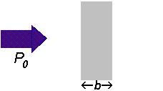
  The amount of radiation absorbed may be measured in a number of ways:
  Transmittance, T= P/P₀
  % Transmittance, %T = 100 T
  Absorbance,
  A = log₁₀P₀/ P
  A = log₁₀1 / T
  A = log₁₀100 / %T
  A = 2 - log₁₀ %T

The relationship between absorbance and transmittance is illustrated in the following diagram:
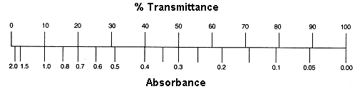
So, if all the light passes through a solution without any absorption, then absorbance is zero, and percent transmittance is 100%. If all the light is absorbed, then percent transmittance is zero, and absorption is infinite.
Conceptually, the transmittance is an easier quantity to understand than the absorbance. If T = 30%, then 30% of the photons passing through the sample reach the detector and the other 70% are absorbed by the analyte. The absorbance is a slightly less intuitive quantity. If A = 0, then no photons are absorbed. If A = 1.00, then 90% of the photons are absorbed; only 10% reach the detector. If A = 2.00, then 99% of the photons are absorbed; only 1% reach the detector. It is the absorbance, however, that displays a simple dependence on the concentration and cell path length (Beer's Law), and thus most chemists choose to report data in terms of absorbance rather than transmittance.
The absorbance of a sample can be related to the concentration of the absorbing species through Beer's law:
A= εbc
where A is absorbance (no units, since A= log₁₀P₀/P), ε is a proportionality constant known as the molar extinction coefficient or molar absorbtivity with the units of Lmol⁻1cm⁻¹. The value of ε is a function of both the particular compound being measured and the wavelength. b is the path length of the sample that is, the path length of the cuvette in which the sample is contained with the units in cm. c is the concentration of the compound in solution, expressed in mol L⁻¹.
A = εbc tells us that absorbance depends on the total quantity of the absorbing compound in the light path through the cuvette. If we plot absorbance against concentration, we get a straight line passing through the origin (0,0).
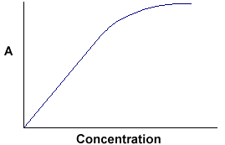 | Note that the Law is not obeyed at high concentrations.

The linear relationship between concentration and absorbance is both simple and straightforward, which is why we prefer to express the Beer’s law using absorbance as a measure of the absorption rather than %T.

EXPERIMENTAL PART
Objective:
To estimate the protein concentration in a given sample by Biuret assay
Introduction and Principle:
The biuret reaction can be used for both qualitative and quantitative analysis of protein. The biuret method depends on the presence of peptides bonds in proteins. When a solution of proteins is treated with cupric ions (Cu²⁺) in a moderately alkaline medium, a purple colored Cu²⁺-peptide complex is formed which can be measured quantitatively by spectrophotometer in the visible region. So, biuret reagent is alkaline copper sulfate solution.
The intensity of the color produced is proportional to the number of peptide bonds that are reacting, and therefore to the number of protein molecules present in the reaction system. The reaction don’t occur with amino acids because the absence of peptide bonds, and also that with di-peptide because presence of only one peptide bond, but do with tri-, oligo-, and poly-peptides. Biuret reaction needs presence of at least two peptide bonds in a molecule.
In this experiment the amount of protein in skimmed-milk is determined by biuret assay. First you perform a biuret assay with various known concentrations of bovine serum albumin. The response is absorbance of the colored product. Graph these data to make a standard curve, concentration on the X axis, and the absorbance on the Y axis. Also perform the biuret assay with your sample. To analyze the data, fit a line or curve through the standards. For the sample, read across the graph from the spot on the Y-axis that corresponds to absorbance of the sample until you intersect the standard curve. Read down the graph until you intersect the X-axis. The concentration of protein in skimmed milk is the value on the X-axis.
Material and apparatus:
- Skimmed milk
- Standard BSA (10 mg/ml)
- Distilled water
- Biuret reagent
- Test tubes
- Test tube rack
- Pipettes
- Spectrophotometer
- Cuvettes
Methods:
- Label 9 test tubes as (1 to 9) and place them in a test tube rack
- Add to each tube the solutions in the following table

Amount of each solution by (ml) | Test tubes
Amount of each solution by (ml) | Standards |  |  |  |  |  | Sample in duplicate |  | blank
Amount of each solution by (ml) | 1 | 2 | 3 | 4 | 5 | 6 | 7 | 8 | 9
Standard BSA | 0.1 | 0.2 | 0.4 | 0.6 | 0.8 | 1 | - | - | -
Distilled water | 0.9 | 0.8 | 0.6 | 0.4 | 0.2 | - | - | - | 1
Sample | - | - | - | - | - | - | 1 | 1 | -
Biuret reagent | 4 | 4 | 4 | 4 | 4 | 4 | 4 | 4 | 4
- Allow standing for 30 min.
- Read the absorbance for each tube against the blank at 540 nm.
- Record your result in the following table.
Test tube | BSA conc (mg/ml) | Absorbance at 540 nm
1
2
3
4
5
6
7
8
- Plot the standard curve using concentration of standard tubes of BSA (mg/ml) against the absorbance at 540 nm.
- Calculate the mean of absorbance of the dublicate sample and obtain the concentration of protein in skimmed milk from the standard curve.

