TUTORIAL-Tolerances and Fits

Problem 1: A gear made from steel is to be assembled on a steel shaft with an interference fit. Nominal diameter of the shaft is 60mm and the pitch diameter of the gear is 120mm. The shaft and the gear hole are machined with IT5 and IT6 qualities respectively. If the fit is based on basic shaft system (BSS), determine the nearest standard fit if the minimum interference is 0.013 mm.
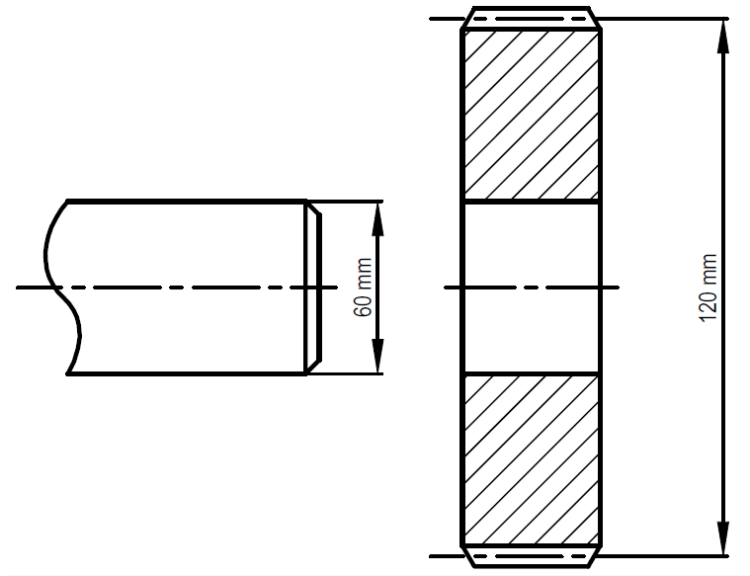

Problem 2: A shaft of 30 mm is machined to IT5 quality. A gear produced from cast iron is to be press-fitted over the shaft as shown in the figure below. The outside diameter of the hub of the gear is 50 mm. The minimum torque to be transmitted by the gear shaft assembly is 25 Nm. The maximum tangential stress in the gear hub is required to be 82 Mpa. Modulus of elasticities and poisson’s ratios for cast iron and for steel are E_{h}=100GPa and E_{s}=207GPa; ϑ_{h}=0.211 ϑ_{s}=0,3 respectively. Determine the nearest standard fit using Basic Shaft System (BSS) if coefficient of friction, f=0.1 and Length of the fit is 20mm.
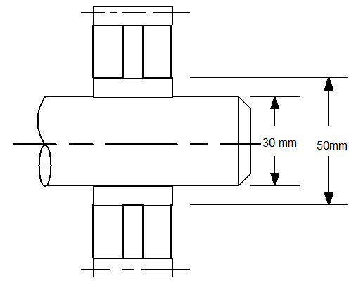

ANSWERS

Answer 1

Fitting is based on BSS, therefore fundamental deviation for shaft will be zero,
Shaft=> IT5 => h5 => $60\left(\frac{0}{-13}\right)-13$ (from table A4-2, IT quality is taken as 13 for IT grade 5 and for 60mm diameter.)

Iso standard of the hole will be determined, IT quality is given as 6,
Hole=> IT6 => ?

I_{min}=0,013 mm = 13µm

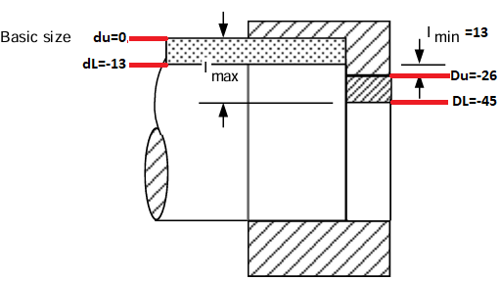

Hole=> $60\left(\frac{-26}{-45}\right)-19$ => from table A4-3, nearest standard is selected as P6.

Result= h5/P6

Answer 2

Nominal dia. =30mm
BSS => h5
IT quality =5
Pressed fit (interference fit)
Hub dia=50 mm
T_{min}=25Nm
σ_{t max}=82 MPa
f=0,1 (coefficient of friction)
L=20 mm (fit length)

$A=2.π.r.L$ $A=2.π.15.20=1885 {mm}^{2}$

$T_{min}=p_{min}.A.f.\frac{d}{2}$ $25000= p_{min}.\left(1885\right).\left(0,1\right).(15)$ $p_{min}=8.84 MPa$

Lame Equations:

$σ_{t_{max}}=p_{max}.\frac{c^{2}+b^{2}}{c^{2}-b^{2}}$ $82=p_{max}.\frac{{25}^{2}+{15}^{2}}{{25}^{2}-{15}^{2}}$ $p_{max}=38,6 MPa$

Radial Interference:

$δ=δ_{hole}+δ_{shaft}$

$δ=\frac{bp}{E_{h}}\left\{\frac{c^{2}+b^{2}}{c^{2}-b^{2}}+μ_{h}\right\}+\frac{bp}{E_{s}}\left\{\frac{b^{2}+a^{2}}{b^{2}-a^{2}}-μ_{s}\right\}$ shaft is solid, a=0 , materials are different;

Then the equation is reduced to;

$$δ=\frac{bp}{E_{h}}\left\{\frac{c^{2}+b^{2}}{c^{2}-b^{2}}+μ_{h}\right\}+\frac{bp}{E_{s}}\left\{1-μ_{s}\right\}$$

Hole (gear)
Eh=100 GPa (cast iron)
µh=0,211 (poisson’s ratio)
b=15mm , c=25mm
Shaft
Es=207 GPa (steel)
µs=0,3 (poisson’s ratio)
a=0 , b=15mm

$δ_{min}=\frac{15.(8,84)}{100000}\left\{\frac{{25}^{2}+{15}^{2}}{{25}^{2}-{15}^{2}}+0,211\right\}+\frac{15.(8,84)}{207000}\left\{1-0,3\right\}$ $δ_{min}=0,0035mm$

$δ_{max}=δ_{min}\left(\frac{p_{max}}{p_{min}}\right)=0,0035\frac{38,6}{8,84}=0,015mm$

Diametral interference:

$I_{min}=2.δ_{min}=2.\left(0,0035\right)=0,007mm=7μm$

$I_{max}=2.δ_{max}=2.\left(0,015\right)=0,030mm=30μm$

Interference fit for BSS

Shaft;
BSS => h5 => $30\left(\frac{0}{-9}\right)-9$
d_{U}=0 µm
d_{L}=-9 µm

I_{min}=7 µm
I_{max}=30 µm
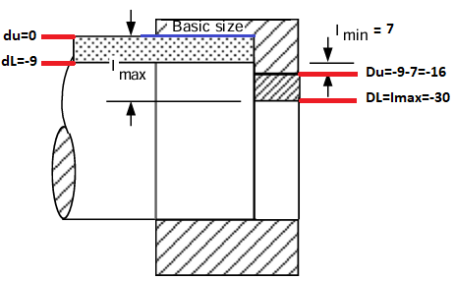

From the figure;
D_{U}=-9-7=-16 µm
D_{L}=I_{max}=-30 µm

So, the tolerance limits of the hole is $30\left(\frac{-16}{-30}\right)$

Nearest standard between this values can be selected;

Selection procedures:
- $D_{U}≤-16 \left(I_{min}=7\right) and D_{L}≥-30 (I_{max}=30)$

- Since DU and DL are negative, we are looking the grades under K8 and for upper deviation. P6, which is -18 near to -16. It is ok.

- When the IT grade is then added; (-18-13)=-31. -31<-30 but it is ok.

Result = h5/P6 = $\left(\frac{0}{-9}\right)/\left(\frac{-18}{-31}\right)$

Upper and lower limits;

Hole = 29,969mm – 29,982mm

Shaft = 29,910mm – 30,000mm

