TUTORIAL-ME 307
Question 1: Using the maximum shear stress (MNST) and maximum normal stress theory (MSST), find the minimum yield strength to be used for the beam shown in the figure. Choose an appropriate material accordingly.
T=300 N.m, M=250 N.m, F=800 N. (Take the safety factor as 2.5).

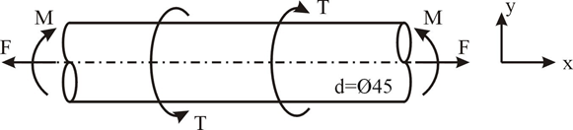

Question 2: The figure shows a belt pulley mechanism which is loaded statically. The shaft is made of AISI 1030 steel with the yield strength of 480MPa. Using distortion energy theory (DET), determine the diameter of the shaft with a factor of safety of 2.
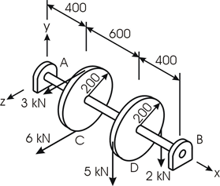

Question 3: A cast iron (brittle) structure is loaded as shown in the figure. The material is ASTM grade 40 and its tensile ultimate strength and the compressive ultimate strength are Sut=293 MPa, Suc=965 MPa respectively. Find the safety factor using the following brittle failure theories, Brittle-Coulomb-Mohr (internal friction) and Modified Mohr.
